FlightAdvice

Systems Analysis and Design Document

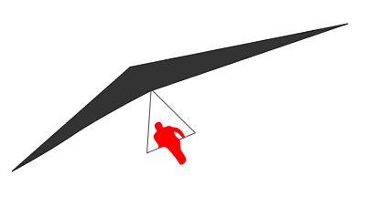

8/14/2016

Wellington Institute of Technology

Nliu Herath

Table of Contents

1. INTRODUCTION 4

Purpose and Scope 4

System Overview 4

2. SYTEM DESIGN 5

Phase 1 - 'Wired' 5

Hardware used for phase 1 5

Block Diagram 6

External Interface Diagram 9

Phase 2 - 'Wireless' 12

Hardware used for phase 2 12

Block Diagram 12

External Interface Diagram 15

2. SYSTEM ARCHITECTURE 18

System Hardware Requirement. 19

Arduino Uno Eleven: 19

Sparkfun Weather Shield: 19

Weather meter: 19

GSM Shield 19

Power Supply, Battery, Batter charging Equipment 19

Dedicated Mobile 19

Personal computer 19

USB cable 19

System Software requirement. 20

Arduino IDE 21

Java IDE 21

WAMP Server 21

Communication Protocol 21

Message Format 21

Sample Message 21

Message Format Description 21

List of Sensor ID's used 22

Database Design 22

1. Weather Station Table 23

2. Sensor Table 23

3. Sensor Data Table 23

Web Design 24

Critical Weather Condition Web Page 24

General Weather Condition Web Page 25

# INTRODUCTION

## Purpose and Scope

The purpose and scope of this document is to provide the customer an overview of the Flight Advice system design, hardware components, software components involved to build the system and to give a general understanding of systems architecture.

This document has been developed by Nilu Herath for project FlightAdvice for the client, Chalinor Baliuag (Lecturer) at Wellington Institute of Technology.

## System Overview

The goal of Flight Advice system is to provide online real time weather information to a unique set of pilots who will engage in hand gliding.

To achieve this goal the Flight Advice system will be implemented in 2 Phases.

The Phase 1 will be solidifying the systems hardware platforms, communication protocol, data processing and data storage mechanisms. This phase will set the stage to enhance the system into next phase, where system will be challenged by real world operational situations.

Phase 1 - System will be developed under controlled conditions placing the weather station in the vicinity of the computer by hardwiring the weather station with the computer.

Phase 2 - Weather station will be placed in a remote location far away from the computer and data will be transmitted via GSM network.

When data is received by the computer it will be stored in the database. The data stored in the database will be used to publish (either processed or raw) to a web site and will be able to access by the client via internet. Client may choose to access information published in the web site by either a computer or via a mobile device.

# SYTEM DESIGN

## Phase 1 - 'Wired'

The objective of the wired phase of the system is to implement the system in a controlled environment. The weather station will be placed close within the proximity of a computer and will be connected to COM port (communication port) via a USB cable. The weather station will be equipped with a set of sensors which will transmit data to the computer at a regular interval. The purpose of wired solution is to establish the communication protocol with Arduino, process sensor data, save data to a database and publish data to a web page.

### Hardware used for phase 1

1. Arduino Uno Eleven
2. Sparkfun Weather Shield - With inbuilt sensors (has sensors for humidity, Temperature, Luminosity and Barometric Pressure)
3. Weather meter (has a wind speed vain, wind direction vain and rain gauge)
4. USB cable
5. Personal computer

### Block Diagram



Figure 1

The block diagram for phase 1 is elaborated by 'Figure 1'.

The main feature of this phase is hard-wiring Arduino board to the computer via a USB cable. Arduino will be transmitting sensor data over the wire to Computer COM port.

This setup provides a stable control environment to implement system component (System Modules). Some of the system modules will be re-used as-is in Phase 2 implementation. Other modules functionality will be extended to meet phase 2 requirements.

### External Interface Diagram



Figure 2

Phase 1 external interface diagram is elaborated by 'Figure 2'.

Block Diagram for Phase 1 is shown by 'Figure 2'. The main feature of this phase is that the Weather station is connected to computer by a USB cable. Sensor data is read by the Controller application on the COM port. After reading the sensor data the Controller application processes the data and sends them to the database. The data stored in the database will be read by the web page.

The computer will power the Arduino board, Sparkfun shield and the Weather meter.

## Phase 2 - 'Wireless'

Wireless phase of the systems implementation mainly targets placing the weather station closer to real world scenario, exposing the weather station to elements. In this phase weather station will be tested upon long distance data transmission, exposure to weather conditions, accuracy of weather data, working with external power source and various other situations. Only difference in this phase for implementation prospective is transmitting data via a GSM (Mobile Network). The sensor data captured will be stored in a computer. Computer will be reading incoming data file, process and string into the database.

### Hardware used for phase 2

1. Arduino Uno Eleven
2. Sparkfun Weather Shield - With inbuilt sensors (Humidity, Temperature, Luminosity and Barometric Pressure)
3. Weather meter (Wind Speed and Wind Direction)
4. GSM Shield
5. Power Supply, Battery, Batter charging Equipment ( Solar Panel, Wind Turbine etc)
6. Dedicated Mobile to receive sensor data and save data to a file
7. Personal computer
8. USB cable

### Block Diagram



Figure 3

Block Diagram for Phase 2 is shown by 'Figure 3'.

The main feature of this phase is distance communication by Weather station to computer via GSM network, transmitting sensor data. To achieve such feet a dedicated mobile will be placed next to the computer to receive and store sensor information. The dedicated mobile and computer will be connected via a USB cable

Once the sensor data is collected to a file in the computer, the sensor data will be read and processed by the Controller Application (Implemented in Java as part of Phase 1 hence extended to read data from a file). The rest of the components implemented by Phase 1 will be re-used as-is to produce intended output to the users.

Powering of Weather station (Arduino Board) will be done by a battery. A solar panel will be used to charge this battery.

### External Interface Diagram



Figure 4

# 2. SYSTEM ARCHITECTURE

## System Hardware Requirement.

1. Arduino Uno Eleven
2. Sparkfun Weather Shield - With inbuilt sensors (Humidity, Temperature, Luminosity and Barometric Pressure)
3. Weather meter (Wind Speed and Wind Direction)
4. GSM Shield
5. Power Supply, Battery, Batter charging Equipment (Solar Panel, Wind Turbine etc)
6. Dedicated Mobile to receive sensor data and save data to a file
7. Personal computer
8. USB cable

### Arduino Uno Eleven:

Arduino Uno Eleven is the main board that the weather station is built on. This board is powered by an external power source. Power will be distributed to the other components attached to this board. Arduino converts the Analog sensor signals to digital signals.

### Sparkfun Weather Shield:

The Sparkfun weather shield is Arduino Uno compatible board. It has inbuilt sensors to read barometric pressure, relative humidity, luminosity, temperature and it contains interfaces for rain, wind speed and wind direction. Weather shield has inbuilt voltage regulators.

### Weather meter:

This kit represents the three core components of weather measurements. They are the wind speed, wind direction and rainfall. Weather meter contains sensors to measure wind speed, wind direction and rain fall.

### GSM Shield

GSM shield will be used to send text messages to a designated mobile via GSM network The GSM shield will be plugged into the Sparkfun weather station.

### Power Supply, Battery, Batter charging Equipment

These components will be used to power Weather station components when weather station is placed in remote location where no utility power is available.

### Dedicated Mobile

The mobile phone will be used to receive text messages from weather station. Once text messages are being received, the contents of the message will be saved to a file system.

### Personal computer

The Person computer will be used to host the Java Progam (Controller Application). This application will be reading data from incoming data sources (Either by COM port or File) and will process and save the data to a database.

### USB cable

USB cable will be used to connect Arduino board with Computer for Phase1. Also this will be used to hardwire dedicated mobile with Computer in Phase 2.

## System Software requirement.

1. Arduino IDE
2. Java IDE
3. WAMP Server
4. Computer Operating System supporting Java VM.

### Arduino IDE

Arduino IDE is used to programme the Arduino Uno board. This IDE will be used at the time of system development to setup Arduino board with sensor data messaging protocol. When introducing new weather station hardware, this IDE will be used to programme the weather station either by customer or technical staff.

### Java IDE

Eclipse IDE will be used at the time of development of controller application.

### WAMP Server

WAMP (Windows Apache MySQL and PHP) server will be used to host and execute controller application. MYSQL database provided by the WAMP server will be used to store sensor data. PHP technology hosted by the WAMP server will be used to implement the web pages. Tomcat web server will be used to publish the website.

## Communication Protocol

The following communication protocol will be used to transmit sensor data from weather station to computer. This is a character based protocol where each character will be occupying a single byte.

The message is formatted to identify the weather station first. The weather station number will be placed at the beginning of the message. Each section separated by ‘#’ will represent individual sensor data reading. Each sensor will be identified by a unique code. Each sensor reading will consist of sensor reading and the unit used.

Single message line produce by Arduino Weather station represent a one round of sensor readings.

### Message Format

X - Characters, 9 - numbers

|  |  |  |  |  |  |  |  |
| --- | --- | --- | --- | --- | --- | --- | --- |
| **X[X..X] or 9[9]** | **#** | **X[X]** | **,** | **9[9..9] or 9[9..9].9[9..9] or X[X..X]** | **,** | **X[X..X]** | **\n** |

Note: The sections coloured in **GREEN** will repeat for each sensor reading read by weather station.

### Sample Message

1#T,21.5,C#H,41.00,%#WS,23,Kmh#WD,N,#R,12,mm#B,34,Pa#L,11,Lux

### Message Format Description

|  |  |  |  |
| --- | --- | --- | --- |
| Field | Message Field | Length | Description |
| 1 | Weather Station ID | Minimum of 1 Char | This will be used to identify the weather station sending the sensor data. This should be a unique number allocated to each weather station. |
| 2 | Sensor Separator-**#** | 1 Char | Data Separator character for each sensor |
| 3 | Sensor ID | Minimum of 1 Char | Each sensor will be assigned a unique sensor id. Please refer table below for more information |
| 4 | Separator-**,** | 1 Char | Data Separator for each sensor reading |
| 5 | Sensor Reading | Minimum of 1 Char | Sensor Reading |
| 6 | Separator-**,** | 1 Char | Data Separator for each sensor reading |
| 7 | Sensor Measurement | Minimum of 1 Char | Sensor Measurement |
| 8 | Line Separator | Control Character | Control Character used to end the sensor data line |

### List of Sensor ID's used

|  |  |
| --- | --- |
| Sensor ID | Description |
| T | Temperature Sensor |
| H | Humidity |
| WS | Wind speed |
| WD | Wind direction |
| R | Rain Fall |
| B | Barometric Pressure |
| L | Light |
| V | Voltage reading |

## Database Design

The data collected by each weather station will be stored in a relational database. MySQL database provided by WAMP server has been chosen for this purpose.

Database Tables:

1. WeatherStation
2. Sensor
3. SensorData

### Weather Station Table

Weather station table will maintain information related to each weather station.

|  |  |  |  |
| --- | --- | --- | --- |
| Table Name: | | weatherstation | |
| Primary Key | | StationId | |
| **#** | **Column Names** | **Data Type** | **Data Length** |
| 1. | StationId | String | 2 |
| 2. | StationName | String | 30 |
| 3. | LocationAddress | String | 200 |
| 4. | GPSCordinate | String | 50 |

### Sensor Table

Sensor table will maintain unique ID’s for each type of sensor attached to the weather station

|  |  |  |  |
| --- | --- | --- | --- |
| Table Name: | | sensor | |
| Primary Key | | sensorId | |
| **#** | **Column Names** | **Data Type** | **Data Length** |
| 1. | SensorId | String | 2 |
| 2. | SensorName | String | 30 |
| 3. | ProductUsed | String | 50 |

### Sensor Data Table

Sensor data table will collect all the sensor readings. This table will collect data per sensor type. Data reading timestamp will also get stored with each sensor reading.

|  |  |  |  |
| --- | --- | --- | --- |
| Table Name: | | sensordata | |
| Primary Key | | Id | |
| Foreign Key: | | sensordata .StationId to weatherstattion.SensorId | |
| Foreign Key: | | sensordata .SensorId to sensor. SensorId | |
| **#** | **Column Names** | **Data Type** | **Data Length** |
| 1. | Id | Integer | Auto generated sequence |
| 2. | StationId | String | 2 |
| 3. | SensorId | String | 2 |
| 4. | SensorReading | String | 8 |
| 5. | ReadingUnit | String` | 3 |
| 6. | ReadingDateTime | Date | Format yyyy-mm-dd hh:mm:sec:msec |

**Addition Requirements:**

The number of records collected by Sensordata table directly contributed to two factors.

1. Number of sensors

2. The minimum time period the data needs to retain (n Number of days).

To process large volume of data efficiently addition indexers may need to get created. Most of the database queries that would retrieve data, would target stationed, sensorid and readingdatetime columns. It’s highly likely these columns will be targeted to create indexers.

## Web Design

Sensor Data collected in the database will be used to present the data to web pages. Apache tomcat web server will be used to host the web site.

The data collected in the database will be read from the web page software (either periodically or on demand) and publish to web pages. These web pages will be able to access by any device which support web browser access via internet.

The web page(s) will publish sensor data either processed or unprocessed as customer‘s requirements.

The web page design will publish critical and general weather conditions as for hang gliding requirements.

1. Critical Weather Conditions: Wind Speed and Wind Direction
2. General Weather Conditions: Temperature, Humidity, Rainfall, Barometric Pressure and Light (Cloud Cover)

### Critical Weather Condition Web Page

This web page publishes weather information identified as critical to Hang Gliding. Depending on the wind speed and wind direction pilots may decide the favorable (or unfavorable) weather condition to carry out hang gliding. Pilots may also use general weather conditions for their decision making process.

Hang Gliding Pilots have come up with a scale on how these critical weather conditions are going to measure.

* If Wind Speed is less than 22.22Km/h – not suitable
* If Wind Speed is between 22.22 to 33.33 Km/h – suitable
* If Wind Speed is over 33.33 Km/h – not suitable (Gusty)

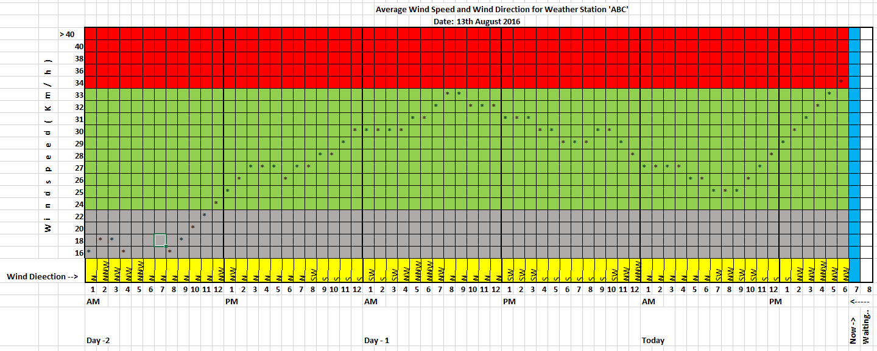

### General Weather Condition Web Page

This web page publishes weather conditions identified as general conditions. The information for each weather condition will be plotted for last 12 hours.

For Temperature

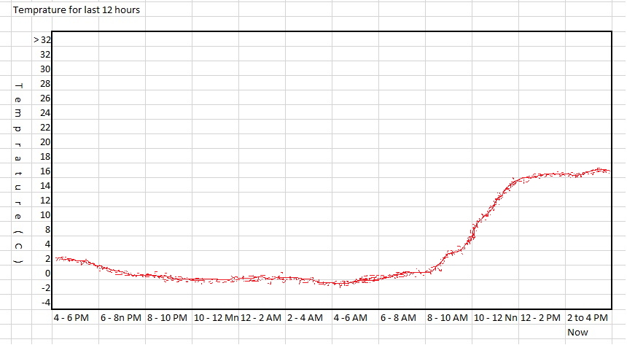

For Humidity

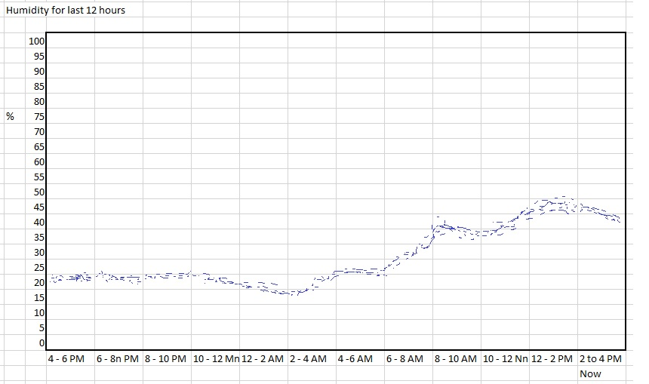

Wind Speed, Wind Direction, Barometric Pressure and Light (Cloud Cover) sensor data will be plotted as similar to Temperature and Humidity graph’s above with different scales.